|  |  |  |  |  |  |  |
| --- | --- | --- | --- | --- | --- | --- |
| **NGX All Share** |  |  |  |  |  |  |
|  | Today's Close | 1 Day Change | 1 Week Change/Level | QTD Change/Level | YTD Change/Level | 52 Week Change/Level |
| NGXASI Index | 47,268.61 | -0.06% | -0.13% | 10.66% | 10.66% | 17.82% |
| Market Cap (N billions) | 25,475.20 | -0.06% | -0.13% | 14.25% | 14.25% | 21.44% |
| Volume Traded (millions) | 179.36 | -26.29% | 1,373.56 | 12,912.32 | 12,912.32 | 93,307.35 |
| Value Traded (N millions) | 2,136.26 | -68.93% | 23,796.73 | 247,984.02 | 247,984.02 | 1,118,282.80 |
| NGN/USD | 417 | 0.04% | 0.16% | -4.21% | -4.21% | 5.89% |
| NGXASI ($) | 113.44 | -0.10% | -0.29% | 15.32% | 15.32% | 10.88% |
| Market Cap ($ millions) | 61,140.00 | -0.10% | -0.29% | 19.07% | 19.07% | 14.29% |

|  |  |  |  |  |  |  |  |  |  |
| --- | --- | --- | --- | --- | --- | --- | --- | --- | --- |
| **Index Performance** |  |  |  |  |  |  |  |  |  |
| ARM Sector Indices | 1 Day Return | 1 Wk Return | 3 Month Return | 6 Month Return | QTD Return | YTD Return | 52 Wk Return | 52 Wk Volatility (SD) | 52 Wk Max Drawdown |
| BANKING | -0.43% | -2.26% | -1.02% | 8.96% | 3.63% | 3.63% | -1.02% | 0.91% | -4.03% |
| BREWERS | 0.09% | -1.19% | -1.02% | 11.66% | 4.56% | 4.56% | -1.02% | 1.44% | -8.43% |
| CEMENT | 0.00% | -0.18% | 12.05% | 10.80% | 6.82% | 6.82% | 12.05% | 1.20% | -6.13% |
| TELECOM | -0.11% | 0.58% | 40.57% | 42.85% | 17.84% | 17.84% | 40.57% | 1.31% | -4.91% |
| PERSONAL CARE | -1.25% | 2.02% | 13.94% | 9.40% | 4.37% | 4.37% | 13.94% | 1.70% | -7.06% |
| CONSTRUCTION | 0.00% | 0.00% | 25.22% | 1.18% | 10.77% | 10.77% | 25.22% | 1.27% | -6.25% |
| FOOD | 0.01% | -1.19% | -3.54% | 0.34% | -5.78% | -5.78% | -3.54% | 0.94% | -6.08% |
| INSURANCE | -0.18% | -0.30% | 18.58% | 13.36% | -3.14% | -3.14% | 18.58% | 1.28% | -3.98% |
| OIL& GAS | 0.38% | 41.13% | 346.99% | 98.11% | 140.55% | 140.55% | 346.99% | 3.57% | -11.70% |
| REAL ESTATE | 0.00% | 0.00% | -1.29% | 0.00% | 0.00% | 0.00% | -1.29% | 0.14% | -2.18% |
| ARM Capitalization Indices |  |  |  |  |  |  |  |  |  |
| Large Cap (Top 10%) | -0.11% | 0.18% | 15.70% | 19.52% | 9.32% | 9.32% | 15.70% | 0.66% | -2.01% |
| Mid Cap (Mid 30%) | 0.35% | -1.18% | 20.65% | 12.71% | 8.08% | 8.08% | 20.65% | 0.51% | -1.71% |
| Small Cap (Bottom 60%) | -1.44% | 227.11% | -149.94% | -181.67% | -38.14% | -38.14% | -149.94% | 146.47% | -2128.82% |

**1 Day Index Return**

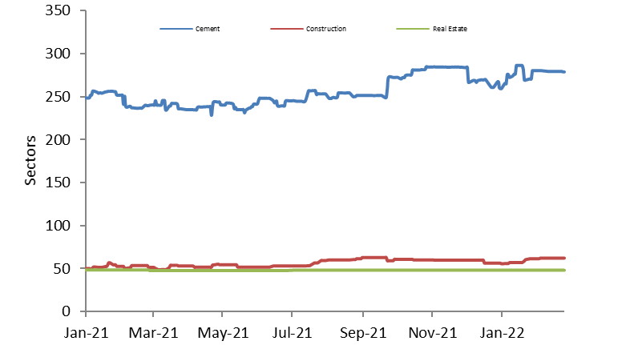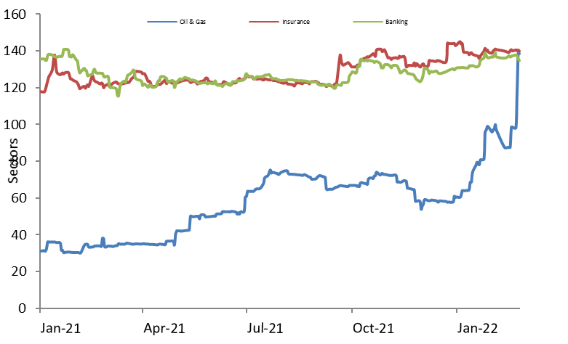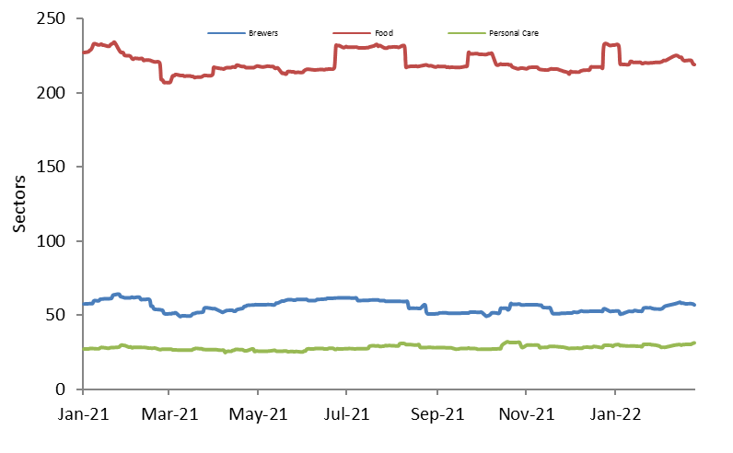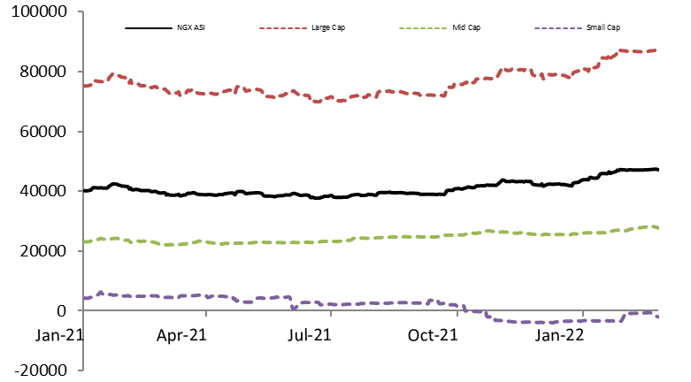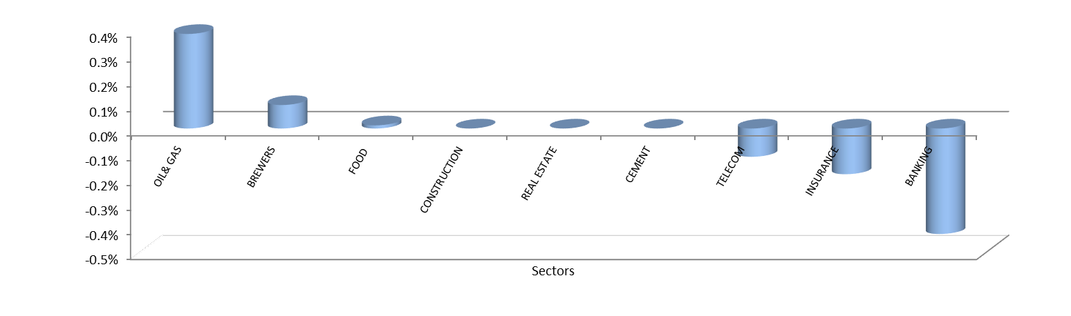

|  |  |  |  |  |  |  |  |  |  |  |  |  |  |  |  |  |
| --- | --- | --- | --- | --- | --- | --- | --- | --- | --- | --- | --- | --- | --- | --- | --- | --- |
| **Coverage Performance** |  |  |  |  |  |  |  |  |  |  |  |  |  |  |  |  |
|  |  | **Market Cap. (N'mn)** | **Closing Price** | **1-day Return** | **1-week Return** | **3-month Return** | **6-month Return** | **52 wk Return** | **QTD Return** | **YTD Return** | **QTD High** | **QTD Low** | **YTD High** | **YTD Low** | **52 Wk High** | **52 Wk Low** |
| **BANKING** |  |  |  |  |  |  |  |  |  |  |  |  |  |  |  |  |
| Access Bank | 31-Dec | 293,618.91 | 10.15 | 0.00% | -1.93% | 12.15% | 10.33% | 12.15% | 9.14% | 9.14% | 10.50 | 7.20 | 10.50 | 9.25 | 10.50 | 7.20 |
| FBN Holdings | 31-Dec | 403,822.04 | 11.25 | 1.81% | -2.60% | 51.01% | 50.00% | 51.01% | -1.32% | -1.32% | 12.70 | 6.90 | 12.00 | 11.00 | 12.70 | 6.90 |
| FCMB | 31-Dec | 67,527.24 | 3.41 | 3.33% | 11.80% | 4.92% | 15.59% | 4.92% | 14.05% | 14.05% | 3.50 | 2.66 | 3.46 | 2.85 | 3.50 | 2.66 |
| GTCO | 31-Dec | 765,210.66 | 26.00 | -1.33% | -3.35% | -21.21% | -6.64% | -21.21% | 0.00% | 0.00% | 36.00 | 23.95 | 28.00 | 25.15 | 36.00 | 23.95 |
| Stanbic IBTC HOLDCO | 31-Dec | 350,000.00 | 35.00 | 0.00% | 0.43% | -20.45% | -11.95% | -20.45% | -2.78% | -2.78% | 52.90 | 34.55 | 38.00 | 34.55 | 52.90 | 34.55 |
| United Bank for Africa | 31-Dec | 272,096.45 | 8.25 | -1.20% | -5.17% | -6.78% | 6.45% | -6.78% | 2.48% | 2.48% | 9.25 | 6.80 | 8.85 | 8.00 | 9.25 | 6.80 |
| Union Bank | 31-Dec | 105,848.79 | 6.25 | 0.00% | -1.57% | 17.92% | 25.00% | 17.92% | 5.93% | 5.93% | 6.40 | 4.55 | 6.40 | 5.40 | 6.40 | 4.55 |
| Wema Bank | 31-Dec | 36,724.19 | 0.93 | -2.11% | -1.06% | 25.68% | 9.41% | 25.68% | 29.17% | 29.17% | 0.97 | 0.55 | 0.97 | 0.78 | 0.97 | 0.55 |
| Zenith Bank | 31-Dec | 830,437.26 | 26.45 | -0.94% | -1.86% | 3.12% | 9.75% | 3.12% | 5.17% | 5.17% | 27.40 | 20.30 | 27.40 | 25.30 | 27.40 | 20.30 |
| Ecobank | 31-Dec | 173,086.84 | 10.85 | -1.36% | -4.41% | 64.39% | 108.65% | 64.39% | 24.71% | 24.71% | 13.10 | 4.70 | 13.10 | 8.60 | 13.10 | 4.70 |
| Fidelity Bank | 31-Dec | 84,316.66 | 2.91 | 1.39% | -4.90% | 11.07% | 23.83% | 11.07% | 14.12% | 14.12% | 3.10 | 2.10 | 3.10 | 2.50 | 3.10 | 2.10 |
| Sterling Bank | 31-Dec | 43,761.44 | 1.52 | -1.94% | -4.40% | -24.75% | 0.66% | -24.75% | 0.66% | 0.66% | 2.04 | 1.43 | 1.73 | 1.50 | 2.04 | 1.43 |
|  |  |  |  |  |  |  |  |  |  |  |  |  |  |  |  |  |
| **BREWERIES** |  |  |  |  |  |  |  |  |  |  |  |  |  |  |  |  |
| Guinness | 30-Jun | 97,882.73 | 65.00 | 0.00% | -4.41% | 260.11% | 109.68% | 260.11% | 66.67% | 66.67% | 74.00 | 18.50 | 74.00 | 39.00 | 74.00 | 18.50 |
| Nigerian Breweries | 31-Dec | 380,596.84 | 48.00 | 0.00% | 0.00% | -17.24% | 0.00% | -17.24% | -4.00% | -4.00% | 63.00 | 45.50 | 48.50 | 45.50 | 63.00 | 45.50 |
| International Breweries | 31-Mar | 16,312.63 | 5.00 | 3.09% | -9.09% | -27.54% | 7.53% | -27.54% | 1.01% | 1.01% | 7.07 | 4.50 | 6.00 | 4.85 | 7.07 | 4.50 |
|  |  |  |  |  |  |  |  |  |  |  |  |  |  |  |  |  |
| **CEMENT & CONSTRUCTION** |  |  |  |  |  |  |  |  |  |  |  |  |  |  |  |  |
| Dangote Cement | 31-Dec | 4,660,578.78 | 273.50 | 0.00% | 0.00% | 21.56% | 11.63% | 21.56% | 6.42% | 6.42% | 284.90 | 204.00 | 284.90 | 250.00 | 284.90 | 204.00 |
| BUA CEMENT | 31-Dec | 2,395,903.05 | 70.75 | 0.00% | 0.00% | -11.56% | 4.04% | -11.56% | 5.52% | 5.52% | 80.00 | 64.35 | 71.95 | 68.00 | 80.00 | 64.35 |
| Lafarge | 31-Dec | 131,537.62 | 24.00 | 0.00% | -8.75% | 7.62% | 7.14% | 7.62% | 0.21% | 0.21% | 30.30 | 19.50 | 27.00 | 24.00 | 30.30 | 19.50 |
| Julius Berger | 31-Dec | 34,980.00 | 26.50 | 0.00% | 0.00% | 48.04% | 1.92% | 48.04% | 18.57% | 18.57% | 27.00 | 17.00 | 26.50 | 21.80 | 27.00 | 17.00 |
| UACN Property DevCo | 31-Dec | 12,285.00 | 17.55 | 0.00% | -10.00% | -12.25% | -10.00% | -12.25% | -9.77% | -9.77% | 23.90 | 17.55 | 19.50 | 17.55 | 23.90 | 17.55 |
|  |  |  |  |  |  |  |  |  |  |  |  |  |  |  |  |  |
| **CONSUMER & PERSONAL CARE** |  |  |  |  |  |  |  |  |  |  |  |  |  |  |  |  |
| PZ Cussons | 31-May | 28,587.43 | 7.20 | 0.00% | 2.86% | 38.46% | 24.14% | 38.46% | 18.03% | 18.03% | 7.20 | 4.15 | 7.20 | 6.10 | 7.20 | 4.15 |
| Unilever | 31-Dec | 53,722.81 | 14.20 | -2.07% | 1.07% | 7.58% | 5.19% | 7.58% | -2.07% | -2.07% | 15.60 | 11.65 | 14.50 | 13.05 | 15.60 | 11.65 |
| Glaxo Smithkline | 31-Dec | 7,653.61 | 6.40 | 0.00% | 5.79% | -8.57% | -5.88% | -8.57% | 7.56% | 7.56% | 7.25 | 5.35 | 6.40 | 5.95 | 7.25 | 5.35 |
|  |  |  |  |  |  |  |  |  |  |  |  |  |  |  |  |  |
| **FOOD & BEVERAGES** |  |  |  |  |  |  |  |  |  |  |  |  |  |  |  |  |
| Cadbury | 31-Dec | 16,809.91 | 8.95 | 0.00% | 0.00% | -0.56% | 5.29% | -0.56% | 1.70% | 1.70% | 10.80 | 7.75 | 9.50 | 8.60 | 10.80 | 7.75 |
| Nascon | 30-Sep | 34,972.59 | 13.20 | 0.00% | -8.33% | -8.97% | -6.71% | -8.97% | 0.00% | 0.00% | 17.55 | 12.90 | 14.50 | 13.05 | 17.55 | 12.90 |
| Dangote Sugar | 31-Dec | 188,400.00 | 15.70 | 0.00% | -7.65% | -18.02% | -11.55% | -18.02% | -9.77% | -9.77% | 21.70 | 15.00 | 18.30 | 15.60 | 21.70 | 15.00 |
| Flour Mills | 31-Mar | 83,975.59 | 32.00 | 0.00% | 0.00% | 19.85% | 6.67% | 19.85% | 12.87% | 12.87% | 35.10 | 27.00 | 35.10 | 28.10 | 35.10 | 27.00 |
| Nestle | 31-Dec | 1,137,461.72 | 1,435.00 | 0.00% | 0.00% | -4.65% | 2.50% | -4.65% | -7.81% | -7.81% | 1,556.50 | 1,350.00 | 1,556.50 | 1,435.00 | 1,556.50 | 1,350.00 |
| Honeywell | 31-Mar | 29,341.73 | 3.70 | 2.78% | -0.80% | 203.28% | 0.00% | 203.28% | 8.82% | 8.82% | 4.28 | 1.09 | 4.02 | 3.20 | 4.28 | 1.09 |
| UACN | 31-Dec | 17,864.04 | 9.30 | -3.12% | -7.00% | 24.00% | -11.43% | 24.00% | -2.11% | -2.11% | 11.45 | 7.15 | 10.25 | 8.90 | 11.45 | 7.15 |
|  |  |  |  |  |  |  |  |  |  |  |  |  |  |  |  |  |
| **OIL& GAS** |  |  |  |  |  |  |  |  |  |  |  |  |  |  |  |  |
| Forte Oil | 31-Dec | 15,499.53 | 11.90 | 0.00% | 0.00% | 0.00% | 0.00% | 0.00% | 0.00% | 0.00% | 21.85 | 11.70 | 13.85 | 11.70 | 21.85 | 11.70 |
| Conoil Plc | 31-Dec | 18,389.73 | 26.50 | 0.00% | 0.00% | 27.10% | 18.57% | 27.10% | 20.45% | 20.45% | 26.50 | 17.00 | 26.50 | 21.30 | 26.50 | 17.00 |
| Mobil Oil | 31-Dec | 82,215.72 | 228.00 | 0.00% | 0.00% | 0.00% | 0.00% | 0.00% | 0.00% | 0.00% | 249.50 | 228.00 | 228.00 | 228.00 | 249.50 | 228.00 |
| Oando | 31-Dec | 58,969.63 | 4.90 | 2.08% | 1.03% | 38.03% | 20.39% | 38.03% | 10.86% | 10.86% | 5.26 | 2.65 | 5.17 | 4.42 | 5.26 | 2.65 |
| MRS Oil | 31-Dec | 3,441.55 | 13.55 | 0.00% | 0.00% | -1.45% | -2.17% | -1.45% | 9.72% | 9.72% | 15.20 | 10.90 | 13.55 | 12.35 | 15.20 | 10.90 |
| Total | 31-Dec | 89,939.33 | 264.90 | 0.00% | 0.00% | 85.24% | 32.98% | 85.24% | 19.38% | 19.38% | 264.90 | 135.90 | 264.90 | 221.90 | 264.90 | 135.90 |
| Eterna Oil | 31-Dec | 7,303.21 | 5.60 | -1.75% | -3.45% | 6.06% | -22.22% | 6.06% | 10.89% | 10.89% | 8.65 | 4.62 | 6.35 | 5.05 | 8.65 | 4.62 |
| SEPLAT | 31-Dec | 572,122.86 | 1,034.00 | 0.00% | 20.25% | 108.43% | 36.11% | 108.43% | 59.08% | 59.08% | 1,034.00 | 490.00 | 1,034.00 | 650.00 | 1,034.00 | 490.00 |
|  |  |  |  |  |  |  |  |  |  |  |  |  |  |  |  |  |
| **INSURANCE** |  |  |  |  |  |  |  |  |  |  |  |  |  |  |  |  |
| AIICO Insurance | 31-Dec | 6,160.14 | 0.70 | 0.00% | 1.45% | -37.50% | -32.04% | -37.50% | 0.00% | 0.00% | 1.59 | 0.59 | 0.84 | 0.67 | 1.59 | 0.59 |
| Continental Re | 31-Dec | 22,721.04 | 2.20 | 0.00% | 0.00% | 0.00% | 0.00% | 0.00% | 0.00% | 0.00% | 2.20 | 2.20 | 2.20 | 2.20 | 2.20 | 2.20 |
| Custodian & Allied | 31-Dec | 42,349.42 | 7.20 | 0.00% | 0.00% | 23.08% | 9.92% | 23.08% | -8.86% | -8.86% | 8.45 | 5.75 | 8.00 | 7.05 | 8.45 | 5.75 |
| Mansard | 31-Dec | 24,780.00 | 2.36 | 0.00% | -1.67% | 98.32% | 168.18% | 98.32% | 1.72% | 1.72% | 2.99 | 0.83 | 2.50 | 2.28 | 2.99 | 0.83 |
| Prestige Assurance | 31-Dec | 2,483.23 | 0.45 | 0.00% | 0.00% | -2.17% | -6.25% | -2.17% | -11.76% | -11.76% | 0.60 | 0.41 | 0.51 | 0.42 | 0.60 | 0.41 |
|  |  |  |  |  |  |  |  |  |  |  |  |  |  |  |  |  |
| **AGRICULTURE** |  |  |  |  |  |  |  |  |  |  |  |  |  |  |  |  |
| Okomu Oil | 31-Dec | 128,777.85 | 135.00 | 0.00% | 5.63% | 45.95% | 22.73% | 45.95% | -4.93% | -4.93% | 142.00 | 90.00 | 142.00 | 127.80 | 142.00 | 90.00 |
| Presco | 31-Dec | 104,500.00 | 104.50 | 1.95% | 0.48% | 47.18% | 31.45% | 47.18% | 19.02% | 19.02% | 105.00 | 68.00 | 105.00 | 87.80 | 105.00 | 68.00 |
|  |  |  |  |  |  |  |  |  |  |  |  |  |  |  |  |  |
| **ICT** |  |  |  |  |  |  |  |  |  |  |  |  |  |  |  |  |
| MTN Nigeria | 31-Dec | 4,142,143.41 | 203.50 | -0.25% | 1.24% | 23.18% | 17.97% | 23.18% | 3.30% | 3.30% | 204.00 | 157.00 | 204.00 | 185.50 | 204.00 | 157.00 |
| AIRTEL AFRICA PLC | 31-Dec | 4,735,270.90 | 1,260.00 | 0.00% | 0.00% | 47.92% | 68.00% | 47.92% | 31.94% | 31.94% | 1,271.00 | 601.00 | 1,271.00 | 955.00 | 1,271.00 | 601.00 |

|  |  |  |  |  |  |  |  |  |  |  |  |  |  |  |
| --- | --- | --- | --- | --- | --- | --- | --- | --- | --- | --- | --- | --- | --- | --- |
| **Top 10 gainers** |  |  |  |  |  |  |  |  |  |  |  |  |  |  |
| **Stocks** | **Closing Price** | **1 Day Return** | **Stocks** | **Closing Price** | **1 Wk Return** | **Stocks** | **Closing Price** | **QTD Return** | **Stocks** | **Closing Price** | **YTD Return** | **Stocks** | **Closing Price** | **52 Wk Return** |
| JOHN HOLT PLC. | 0.86 | 8.86% | FIRST CITY MONUMENT BANK PLC. | 3.41 | 11.80% | ACADEMY PRESS PLC. | 1.77 | 254.00% | ACADEMY PRESS PLC. | 1.77 | 254.00% | ACADEMY PRESS PLC. | 1.77 | 490.00% |
| REGENCY ALLIANCE INSURANCE COMPANY PLC | 0.42 | 7.69% | COURTEVILLE BUSINESS SOLUTIONS PLC | 0.60 | 11.11% | R T BRISCOE PLC. | 0.63 | 215.00% | R T BRISCOE PLC. | 0.63 | 215.00% | ROYAL EXCHANGE PLC. | 1.35 | 486.96% |
| LINKAGE ASSURANCE PLC | 0.58 | 7.41% | JOHN HOLT PLC. | 0.86 | 8.86% | S C O A NIG. PLC. | 2.83 | 172.12% | S C O A NIG. PLC. | 2.83 | 172.12% | MORISON INDUSTRIES PLC. | 2.18 | 344.90% |
| UBA CAPITAL | 13.90 | 5.30% | REGENCY ALLIANCE INSURANCE COMPANY PLC | 0.42 | 7.69% | LEARN AFRICA PLC. | 1.98 | 69.23% | LEARN AFRICA PLC. | 1.98 | 69.23% | GUINNESS NIG PLC | 65.00 | 260.11% |
| MULTIVERSE PLC | 0.24 | 4.35% | GLAXO SMITHKLINE CONSUMER NIG. PLC. | 6.40 | 5.79% | GUINNESS NIG PLC | 65.00 | 66.67% | GUINNESS NIG PLC | 65.00 | 66.67% | R T BRISCOE PLC. | 0.63 | 215.00% |
| SOVEREIGN TRUST INSURANCE PLC | 0.24 | 4.35% | MULTIVERSE PLC | 0.24 | 4.35% | SEPLAT PETROLEUM DEVELOPMENT COMPANY LTD | 1,034.00 | 59.08% | SEPLAT PETROLEUM DEVELOPMENT COMPANY LTD | 1,034.00 | 59.08% | HONEYWELL FLOUR MILL PLC | 3.70 | 203.28% |
| FIRST CITY MONUMENT BANK PLC. | 3.41 | 3.33% | AIICO INSURANCE PLC. | 0.70 | 1.45% | COURTEVILLE BUSINESS SOLUTIONS PLC | 0.60 | 57.89% | COURTEVILLE BUSINESS SOLUTIONS PLC | 0.60 | 57.89% | LASACO ASSURANCE PLC. | 1.03 | 178.38% |
| INTERNATIONAL BREWERIES PLC. | 5.00 | 3.09% | MTN NIGERIA PLC | 203.50 | 1.24% | ROYAL EXCHANGE PLC. | 1.35 | 53.41% | ROYAL EXCHANGE PLC. | 1.35 | 53.41% | UBA CAPITAL | 13.90 | 178.00% |
| NPF MICROFINANCE BANK PLC | 2.10 | 2.94% | SOVEREIGN TRUST INSURANCE PLC | 0.24 | 0.00% | E-TRANZACT INTERNATIONAL PLC | 2.66 | 40.74% | E-TRANZACT INTERNATIONAL PLC | 2.66 | 40.74% | COURTEVILLE BUSINESS SOLUTIONS PLC | 0.60 | 172.73% |
| HONEYWELL FLOUR MILL PLC | 3.70 | 2.78% | E-TRANZACT INTERNATIONAL PLC | 2.66 | 0.00% | UBA CAPITAL | 13.90 | 40.40% | UBA CAPITAL | 13.90 | 40.40% | VITAFOAM NIG PLC. | 21.30 | 137.99% |
| **Top 10 Losers** |  |  |  |  |  |  |  |  |  |  |  |  |  |  |
| **Stocks** | **Closing Price** | **1 Day Return** | **Stocks** | **Closing Price** | **1 Wk Return** | **Stocks** | **Closing Price** | **QTD Return** | **Stocks** | **Closing Price** | **YTD Return** | **Stocks** | **Closing Price** | **52 Wk Return** |
| UNITY BANK PLC | 0.49 | -2.00% | MUTUAL BENEFITS ASSURANCE PLC. | 0.25 | -10.71% | N.E.M INSURANCE CO (NIG) PLC. | 3.95 | -12.22% | N.E.M INSURANCE CO (NIG) PLC. | 3.95 | -12.22% | NIGERIAN ENAMELWARE PLC. | 16.20 | -26.70% |
| UNILEVER NIGERIA PLC. | 14.20 | -2.07% | LIVESTOCK FEEDS PLC. | 1.70 | -12.37% | CUTIX PLC. | 2.30 | -12.88% | CUTIX PLC. | 2.30 | -12.88% | INTERNATIONAL BREWERIES PLC. | 5.00 | -27.54% |
| WEMA BANK PLC. | 0.93 | -2.11% | TRANSNATIONAL CORPORATION OF NIGERIA PLC | 1.08 | -14.29% | C & I LEASING PLC. | 3.60 | -14.29% | C & I LEASING PLC. | 3.60 | -14.29% | UNITY BANK PLC | 0.49 | -30.00% |
| U A C N PLC. | 9.30 | -3.12% | CUTIX PLC. | 2.30 | -14.81% | REGENCY ALLIANCE INSURANCE COMPANY PLC | 0.42 | -17.65% | REGENCY ALLIANCE INSURANCE COMPANY PLC | 0.42 | -17.65% | DAAR COMMUNICATIONS PLC | 0.20 | -33.33% |
| MUTUAL BENEFITS ASSURANCE PLC. | 0.25 | -3.85% | NIGER INSURANCE CO. PLC. | 0.23 | -17.86% | INTERCONTINENTAL WAPIC INSURANCE PLC | 0.46 | -17.86% | INTERCONTINENTAL WAPIC INSURANCE PLC | 0.46 | -17.86% | GREIF NIGERIA PLC | 5.45 | -33.54% |
| CHAMS PLC | 0.21 | -4.55% | LEARN AFRICA PLC. | 1.98 | -24.14% | UPDC REAL ESTATE INVESTMENT TRUST (REIT) | 3.65 | -17.98% | UPDC REAL ESTATE INVESTMENT TRUST (REIT) | 3.65 | -17.98% | UPDC REAL ESTATE INVESTMENT TRUST (REIT) | 3.65 | -33.64% |
| NIGER INSURANCE CO. PLC. | 0.23 | -8.00% | R T BRISCOE PLC. | 0.63 | -32.98% | SOVEREIGN TRUST INSURANCE PLC | 0.24 | -20.00% | SOVEREIGN TRUST INSURANCE PLC | 0.24 | -20.00% | C & I LEASING PLC. | 3.60 | -36.84% |
| LASACO ASSURANCE PLC. | 1.03 | -8.85% | COMPUTER WAREHOUSE GROUP PLC | 1.10 | 0.00% | LIVESTOCK FEEDS PLC. | 1.70 | -20.93% | LIVESTOCK FEEDS PLC. | 1.70 | -20.93% | AIICO INSURANCE PLC. | 0.70 | -37.50% |
| MCNICHOLS PLC | 0.70 | -9.09% | PHARMA-DEKO PLC. | 1.97 | 0.51% | MCNICHOLS PLC | 0.70 | -23.08% | MCNICHOLS PLC | 0.70 | -23.08% | FTN COCOA PROCESSORS PLC | 0.36 | -50.00% |
| ROYAL EXCHANGE PLC. | 1.35 | -9.40% | MCNICHOLS PLC | 0.70 | 0.00% | MUTUAL BENEFITS ASSURANCE PLC. | 0.25 | -24.24% | MUTUAL BENEFITS ASSURANCE PLC. | 0.25 | -24.24% | COMPUTER WAREHOUSE GROUP PLC | 1.10 | -56.69% |

Copyright © 2022 Asset & Resource Management Company Limited (“ARM”).

All rights reserved. Unauthorized use, reproduction, distribution or disclosure of this document is strictly prohibited.

This material has been issued by Asset & Resource Management Company Limited (“ARM”), a Company regulated by the Nigerian Securities and Exchange Commission. The analyst(s) primarily responsible for preparing this research report, in whole or in part, certifies that with respect to each

security or issuer covered; all of the views expressed accurately reflect his/her personal views about the subject securities and issuers and no part of his/her compensation was, is, or will be, directly or indirectly, related to the inclusion of specific recommendations or views in the report.

This research report is based on information from sources that ARM, and its analysts believe to be reliable. Neither ARM nor any of its research analysts, nor any member of the ARM Group, gives any representation or warranty, express or implied, or undertaking of any kind or assumes

responsibility or liability of any kind with respect to the accuracy or completeness of the information set out in this report or any third party’s use (or the results of such use) of such information. This report is provided solely for informational purposes and is not to be construed as providing advice, recommendations, or endorsements of any kind whatsoever. The investments and strategies discussed here may not be suitable for all investors; counsel of investment advisor should be obtained with regard to such investments and or strategies. This research report is not a replacement for advice from an accountant, lawyer, personal finance advisor or other category of investment advisor. The investments discussed in this report may oscillate in price or value. Opinions and information provided are made as of the date of the report issue and are subject to change without notice. This research report is not intended as an offer or solicitation for the purchase or sale of any financial instrument. Reference herein to any specific security or financial instrument does not necessarily constitute or imply its endorsement or recommendation by ARM, its directors, officers, employees or designated agents. Members of ARM may act as broker, advisor or lender, or make a market in any investments or issuers referenced in this report. Further information on any of the securities discussed herein may be obtained upon request to ARM. By accepting this document, you agree to be bound by the foregoing limitations.